Transmission Cross Section Mode Stir

Geometry description:
Cube with a square aperture for transmission cross section calculation
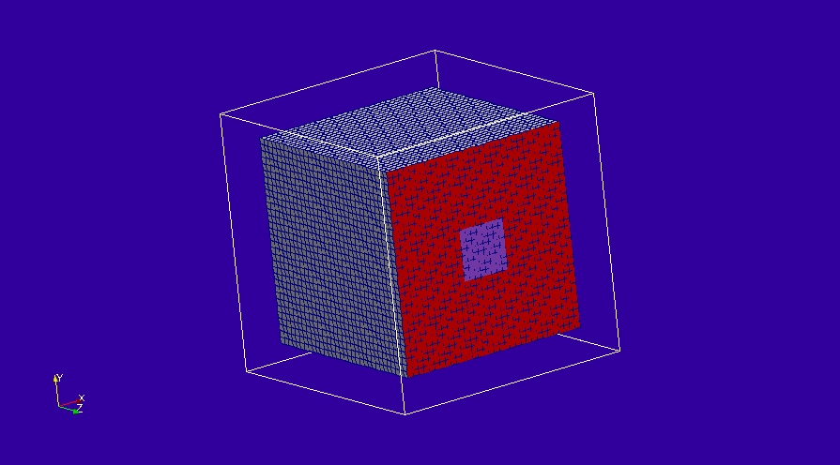

Material description:
All materials are PEC or free space

Mesh:
Δl=5mm

Excitation:
Random excitation on mode stirred boundary

Output:
- Field at a point inside the box
- Field averaged over a volume inside the box
- Frequency Domain Power transmitted through the aperture

Runtime:
200ns

Other Notes:

Post processing:
The post processing for transmission cross section calculation is performed for both the field at a point and the field averaged over a volume. The results of post processing both with and without frequency averaging (frequency stirring) are shown.

Reference results:

GGI_TLM Input file:
# mode_stir chamber test for aperture transmission cross section calculation

Mesh_outer_boundary_dimension
-0.10 0.10 -0.10 0.10 -0.10 0.10

Mesh_cell_dimension
0.005

Outer_boundary_reflection_coefficient
0.0 0.0 0.0 0.0 0.0 0.0

Volume_list
1 Number of volumes (integer)
1 VOLUME_NUMBER (integer) ! output volume
rectangular_block2
-0.005 -0.005 -0.005 0.005 0.005 0.005 volume parameters (n*real)
0.0 0.0 0.0
-0.02 -0.01 -0.03

Surface_list
3 Number of surfaces (integer)
1 surface_number (integer) ! inner mode stirred chamber
rectangular_block2
-0.08 -0.08 -0.08 0.08 0.08 0.08 surface parameters (n*real)
0.0 0.0 0.0
0.0 0.0 0.0
2 surface_number (integer) ! PEC face of mode stirred chamber
rectangle
0.16 0.16 surface parameters (n*real)
0.0 0.0 0.0
0.0 0.0 0.08
3 surface_number (integer) ! aperture in mode stirred chamber
rectangle
0.04 0.04 surface parameters (n*real)
0.0 0.0 0.0
0.0 0.0 0.08

Surface_material_list
3 Number of surface materials (integer)
1 SURFACE_MATERIAL_NUMBER
PEC
1 number of surfaces
1 surface list
1 surface orinetation list
2 SURFACE_MATERIAL_NUMBER
DISPERSIVE
MATERIAL_DIRECTORY/Rsheet=1e-8
1 number of surfaces
2 surface list
1 surface orinetation list
3 SURFACE_MATERIAL_NUMBER
DISPERSIVE
MATERIAL_DIRECTORY/Rsheet=1000
1 number of surfaces
3 surface list
1 surface orinetation list

Point_list
2 Number of points (integer)
1 POINT_NUMBER (integer)
-0.02 -0.01 -0.03 output point coordinates
0.0 0.0 0.0
0.0 0.0 0.0
2 POINT_NUMBER (integer)
0.02 0.03 0.04 output point coordinates
0.0 0.0 0.0
0.0 0.0 0.0

Mode_stir_surface_list
1 Number of mode_stir_surfaces (integer)
1 MODE_STIR_SURFACE NUMBER
1.0 ! boundary condition voltage reflection coefficient
1.0 ! amplitude of random impulse excitation on the boundary
1 ! number of geometric surfaces in this mode_stir_surface
1 ! surface list - surface 0 is the outer boundary
-1 ! surface orientation list

Excitation_function_list
1 ! number of excitation functions
1 EXCITATION FUNCTION NUMBER
impulse
1.0

#Excitation_point_list
1 ! number of output points
1 ! EXCITATION POINT NUMBER
1 ! excitation function number
2 ! excitation point
Ex
centre
soft

Output_point_list
1 ! number of output points
1 ! OUTPUT NUMBER
1 ! output point
Ey
zmax
####centre

Output_volume_average_list
1 ! number of output volumes
1 ! OUTPUT NUMBER
1 ! output volume
Ey

Frequency_domain_power_surface_list
1 ! number of frequency domain power surfaces
1 ! FREQUENCY DOMAIN POWER SURFACE NUMBER
3 ! geometric surface number
1 ! side of surface for output
100e6 10e9 1000 ! fmin fmax n_frequencies for power output

Simulation_time
100e-9

GGI_TLM result
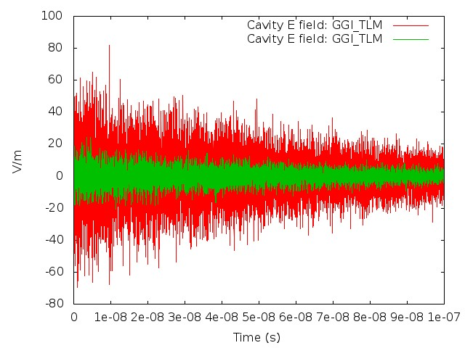
Time Domain field
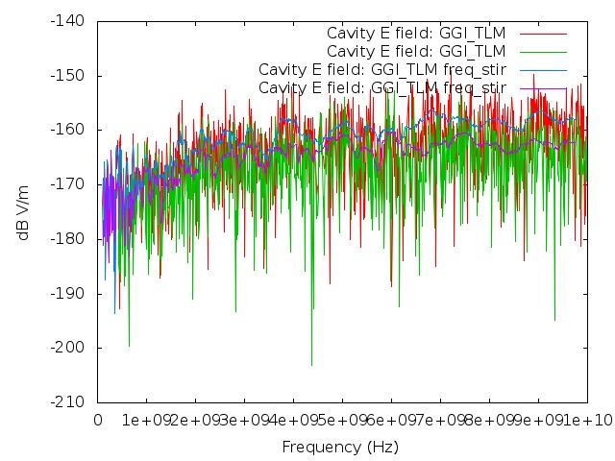
Frequency Domain Field

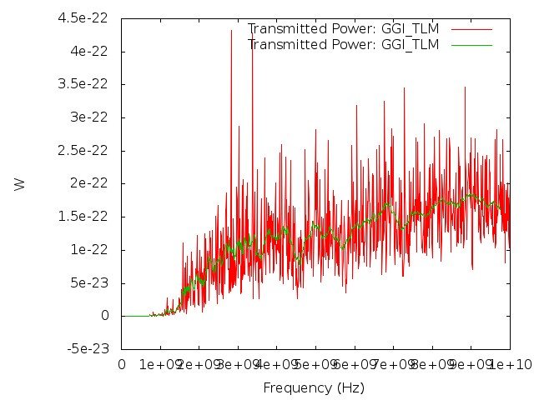
Power transmitted through the aperture
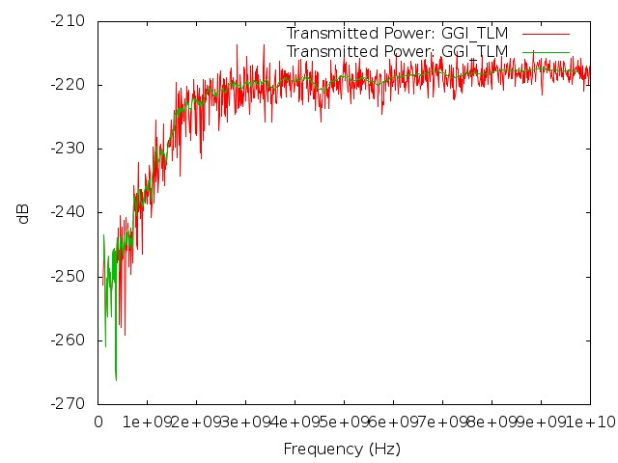
Power transmitted through the aperture(dB)
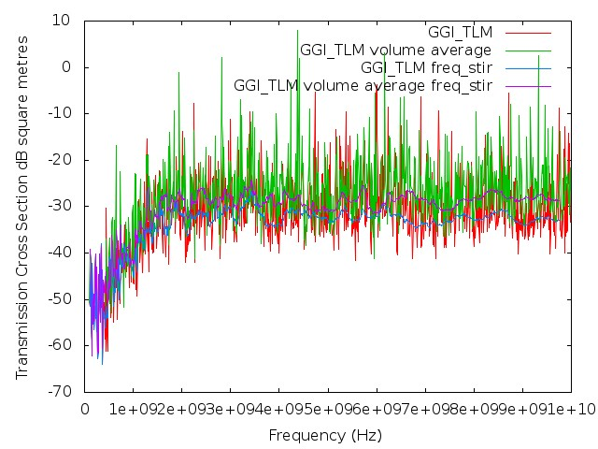
Transmission cross section

